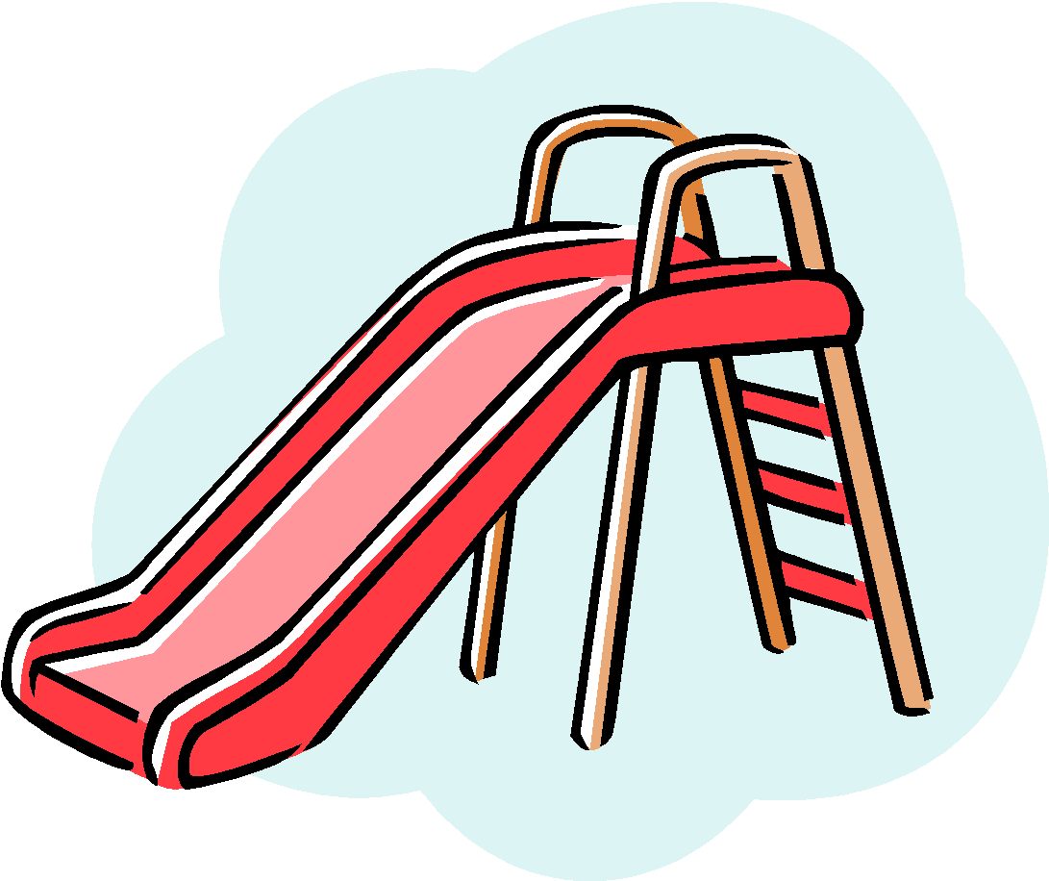
Birch Lane Summer Recreation 2023
About Our Program

Welcome to the 2023 Birch Lane Summer Recreation Program. We have many fun and exciting activities planned for the summer. Below you will find information about our program along with some helpful tips to make your child’s summer recreation experience a positive one. We look forward to welcoming your child to our program and hope to make this summer a wonderful experience!

Birch Lane Summer Recreation Office Phone #
(516)-308-5180

VISIT OUR WEBSITE:
http://www.birchlanesummerrec.weebly.com
FOLLOW US ON TWITTER @BLSummerRec for the Latest Updates/News

Our website will allow you to:

- Learn additional information about our program
- Meet our staff
- View a calendar of events
- Complete permission slips via Google Form
- View Frequently Asked Questions (FAQs)

Summer Recreation runs from Wednesday, July 5th to Friday, August 4th

- Camp hours are 9 AM to 3 PM.

- Campers are not permitted in the building prior to 9 AM.

- If picking up your child at lunchtime or any other unscheduled release time, please be prepared to show identification. No child will be released without proper identification. Please be sure to include the name of any individual that you wish to pick up your child on their contact form. No child will be released to an individual whose name is not listed on the emergency contact form.

- Campers will not be released between 2:45 PM and the normal dismissal time of 3 PM without prior notification to ensure the safety of all campers. Please inform the front desk prior to dismissal time (in the form of a written note) if you need to pick up your child earlier than the regular dismissal time.

Daily Items to Bring to Summer Recreation:
- Sneakers (strongly recommended) – no child will be allowed to play physical activities in loose footwear such as sandals or crocs
- Nutritious bagged lunch (labeled with your child’s name & group)
- Water bottle (labeled with your child’s name & group)
- Sunscreen (for reapplication) - Our staff is not permitted to apply sunscreen on your child. Please apply sunscreen on your child prior to coming to summer recreation.

Tuesday & Thursday Afternoons - a bathing suit, towel, water shoes, and a change of clothes
- If your child would like to participate, groups will be given time to use the sprinkler, weather permitting. Water shoes or any type of secure footwear must be worn at all times.
- Please inform your child’s counselor if you would like your child to go in the sprinkler in their sneakers (otherwise they will not be allowed). No sandals, crocs, or other types of loose footwear will be permitted.
- Parents of younger campers are encouraged to dress their child in a bathing suit prior to camp, especially if they are not used to changing clothes.

Field Trips –
- Optional activities that require a completed Google Form permission slip and an additional fee.
- CASH is the only form of payment accepted for field trips/activities.
- Field trip permission slips must be filled out using the Google Forms provided. Google Forms are accessible through the QR code on our camp activities board or on our website. Permission slips must be filled out first. Once the slip has been completed, payment must be received at the summer recreation desk in order to be registered.
  - Please note that your child is not officially registered for the activity until BOTH permission slip and payment are received. We cannot save spaces. Thank you for your understanding.
- Unless otherwise specified, the field trip permission slip/fee is due the day before the field trip at 10 AM (if spots remain). There are no exceptions to this rule.
- Due to bus limitations, safety concerns, and early notice required by some of our vendors, certain field trips will be limited on a first-come, first served basis. This information will be posted when the week’s activities become available.
- There is still a full day of activities/supervision at Birch Lane for campers who do not participate.

Food/Drink Sales & Food Allergies
- Ice pops/candies/chips/drinks will be made available for purchase during select times of the day.
  - Profits from these sales support our annual Carnival.
- Please make the director aware of any food allergies your child has.
- No food can be distributed at camp without the written consent of a parent/guardian.
- Permission slips will be distributed in advance of any food distribution. (e.g. special events/parties)
- Food/Drink Sold Includes: Freeze Pops, Water, Gatorade/Powerade, Welch's Fruit Snacks, Lays/Ruffles/Wise Potato Chips, Cheetos/Cheez Doodles, Doritos, Fritos, Dipsy Doodles, Wise Popcorn w/ Butter, Cheez-Itz, Pringles, Rice Krispies Treats, Pop Tarts, GoldFish, Dunkaroos, Oreos, Swedish Fish, Skittles, Starburst, Tootsie Pops, Dum-Dum Pops, Ring Pops, Sour Patch Kids, Black Forest Gummy Bears, & Air Heads.

For any questions or concerns, please see our staff:
Director: Mr. Siemsen

Arts & Crafts Director: Ms. Diamond

Assistant Director: Ms. Fountain

